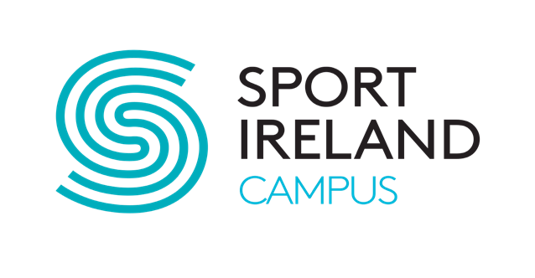
Child Safeguarding Statement

The Children First Act 2015 requires that NSCDA (Operations) Ltd on The Sport Ireland Campus publish a Child Safeguarding Statement. This is a written statement that specifies the services being provided and the principles and procedures to be observed to ensure that a child availing of our services is safe from ‘harm’. It also includes an assessment of any risk of ‘harm’ and specifies the procedures in place to manage these.

Our Risk Assessment

We have assessed that we have the right people, policies & procedures and practice in place to help protect children from harm. Where we need to improve, our risk assessment has identified the necessary actions required.

Viewing / Requesting our Child Safeguarding Statement

A full copy of our Child Safeguarding statement is available to view on request at our main reception desk in the Sport Ireland National Aquatic Centre.
Copies of our Safeguarding Children and Young Adults policy and Safeguarding
Vulnerable Adults policy are available to view on request from our main reception desk in the Sport Ireland National Aquatic Centre.
Signed and dated copies of our Child Safeguarding Statement and Risk Assessment can also be requested from our Relevant Person and Designated Liaison Person, details below.

Aoife Drew – Compliance Officer
Sport Ireland National Sports Campus | Snugborough Road | Blanchardstown | Dublin 15 Office Location: National Indoor Arena
(T) 01 6464361 (E) AoifeDrew@sportirelandcampus.ie (M) 086-4669366

